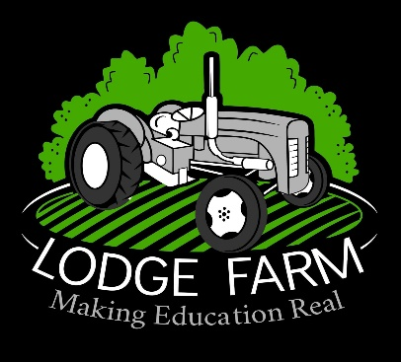

Employability and Careers Policy

Reviewed and modified by: | Natalie Varnham- Business Manager
Signature:
Approved by: | Joy Brown – Head Teacher
Signature:
Date: | 14.09.24
Next review due by: | 13.09.25

This policy summarises the statutory guidance and recommendations. It then outlines the provision of careers education, work experience and provider access.

Introduction
Lodge Farm ensures an inspiring and engaging careers programme tailored to the needs and requirements of each student.
This is achieved through nurturing student interests and guiding in the appropriate direction through training and career based opportunities.

Aims and Objectives

Aims
The overall aim is to deliver professional careers education, information, advice and guidance. Careers guidance will be delivered by an external careers adviser and an onsite employability adviser. Students will be given the opportunity within the careers programme to gain employability skills and will be supported in managing their careers pathway. Preparing students for a smooth transition into work and/or further education outside of Lodge Farm is key, as well as promoting their independence through guided learning and experiences.

- Provide the correct and required information and experiences to further student career knowledge and employability skills.
- Inspire, empower and motivate students to develop their individual self, integrating them as a functioning member of society, and strengthening their ability to work.

Objectives

Learners will have access to the following:
- An external careers adviser for impartial 1:1 careers guidance
- A careers education programme which will promote employability skills, self-awareness of their skills and interests and allows them to explore future options
- An understanding of education, training and employment routes

Students will have to opportunities to go on work experience, visit colleges and universities, industry trips, employer talks within school, create a CV and practice interview techniques.

Learners will be able to:
- Try out different work experience opportunities
- Gain an insight in to the Labour Market
- Gain an understanding of skill sets and how skills are transferable
- Understand how to gain working opportunities through using CV’s, application forms and attending interviews
- Develop skills that employers look for including resilience, teamwork and problem solving
- Have access to paper and online resources to support their careers exploration
- Have access to impartial information on options Post 16 and Post 18
- Make their own career plan
- Start to independently make action plans for the future
- Use coping strategies to help manage their transitions
- Look for opportunities and know who to ask for support if required
- Complete application forms for education and work and update CV’s as required
- Have access to career talks by employers, work experience, college visits and careers guidance interviews

Statutory Requirements and Recommendations

The careers provision at Lodge Farm is in line with the statutory guidance developed by the Department for Education, which refers to Section 42A and 45A of the Education Act 1997.
This states that all schools should provide independent careers guidance from Years 8 -13 and that this guidance should:
- be impartial
- include information on a range of pathways, including apprenticeships
- be adapted to the needs of the pupil
In addition, the school is compliant with the careers guidance that the government set out for delivery from 5 January 2018: ‘Careers Guidance and Inspiration for young people in schools.’ This states that all schools must give education and training providers the opportunity to talk to students about approved technical qualifications and apprenticeships.

Pupil Entitlement:
All pupils in years 8-13 are entitled:
• to find out about technical education qualifications and apprenticeships opportunities, as part of a careers programme which provides information on the full range of education and training options available at each transition point;
• to hear from a range of local providers about the opportunities they offer, including technical education and apprenticeships – through options events, assemblies and group discussions and taster events;
• to understand how to make applications for the full range of academic and technical courses.

