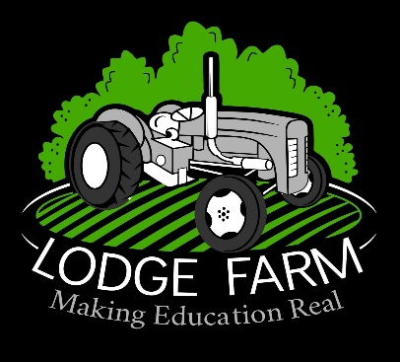

Career Education Information Advice and Guidance Policy

Reviewed and modified by: | Natalie Varnham- Business Manager
Signature:
Approved by: | Joy Brown – Head Teacher
Signature:
Date: | 05/09/2023
Next review due by: | 04/09/2024

Career Education Information Advice and Guidance Policy

Introduction

1. The careers provision at St Peter’s School has been designed to ensure that all of our students are supported to make informed decisions about their future career. We believe that careers provision encourages students to raise their aspirations and to work hard to achieve the best possible grades to ensure that they can move onto the next stage of their learning. Support of provision can have a positive impact on academic achievement across the school, developing students’ confidence and self-esteem. Good provision can help break down gender stereotypes, and show students that all careers are open to them.

Our careers support and guidance is to ensure that we meet the differing needs of all students. Careers education is delivered through PD sessions, through activities and events that take place both in and out of school, and all curriculum areas make links between the learning in the lesson and careers. All of the activities and events that we deliver are monitored and evaluated to ensure that they are relevant to the needs of every student.

Aim and purpose

2. Our careers provision has been designed to

- Prepare our students for the transition to life beyond Lodge Farm Education, whether that be further/higher education, apprenticeships or the world of work
- Support students to make informed decisions which are suitable and ambitious for them
- Provide students with well-rounded experiences both in school and out of school
- Develop essential skills (communication/presenting/leadership/resilience) which will support students in their careers
- Demonstrate to students how their learning across the curriculum links to careers

Careers provision at Lodge Farm Education

- Our careers provision follows these principles of good practice:

  - Careers and essential skills are delivered both within our Personal Development programme and across the curriculum. All teachers have a role to play in our provision, and can show students how relatable lessons are to future careers.
  - We promote high quality work experience to students across the school, and support students at Post 16.
  - We work with a range of external organisations such as National Careers Service, Future
  - We work hard to prevent all forms of stereotyping and discrimination in the careers provision that we provide. Males and females from all backgrounds are encouraged to consider the widest possible range of work experience.
  - We support on hand to help with CV building activities, mock interviews and how to write a letter of application.

